Name | Shirt Option | Color | Size | Quantity | Total Due | Payment Type
 | Example: AW | Lavender | XL | 1 | 30 | Cash/Check/Venmo
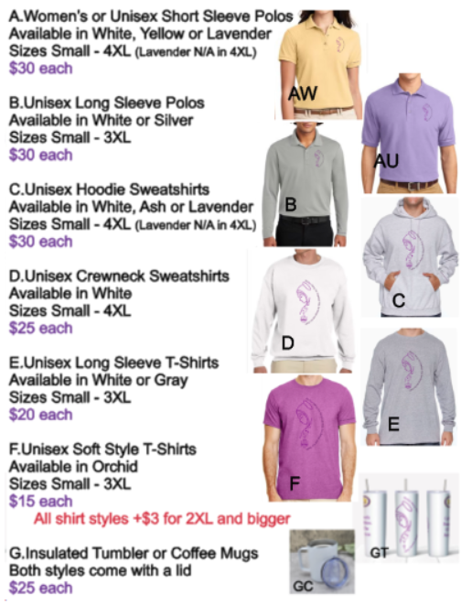
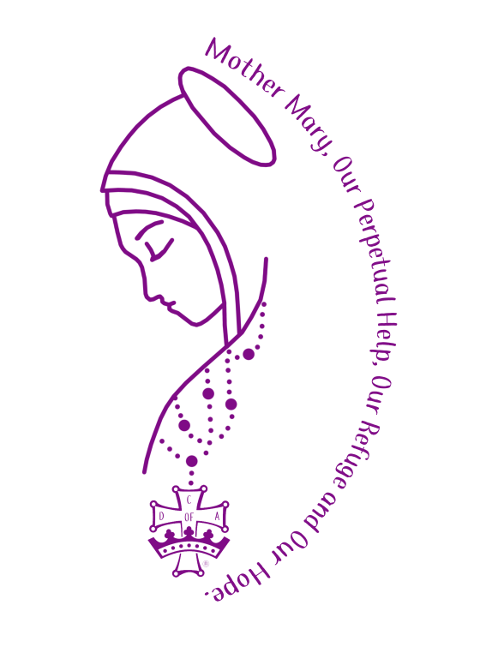

Image to the left will be on the front of the shirt, either large on the front or small on the chest.

The words North Dakota Catholic Daughters will be on the cuff of the sleeve on all shirt options
